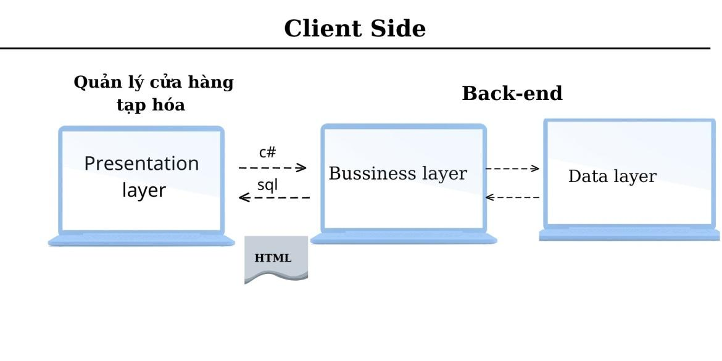

[**https://www.canva.com/design/DAFAw4gN5pw/pD72kxeJGkJap5Yv9bF8FQ/edit#**](https://www.canva.com/design/DAFAw4gN5pw/pD72kxeJGkJap5Yv9bF8FQ/edit#)